

# DATA STRUCTURES AND ALGORITHMS LAB

# PROJECT REPORT

## SPRING - 2023

**SNAKE & TIC-TAC-TOE GAMES**

## Course Instructor

Miss Faiza Khan

## Lab Instructor

Miss Saba Naeem

## GROUP MEMBERS

Muhammad Sharjeel Siddiqui (02- 235221-016)

Muhammad Umar Khan (02- 235221-021)

Abdul Ghaffar (02- 235221-009)



**TABLE OF CONTENT**

1. Abstract
2. Introduction
3. Objectives
4. Inputs
5. Outputs
6. Features
7. Output Screenshots
8. System Testing
9. Conclusion



**ABSTRACT**

This report presents a C++ data structure and algorithms games project that includes two classic games: Snake and Tic Tac Toe. The project incorporates various functionalities such as gameplay, high scores, customization options, and different difficulty levels. The games utilize data structures and algorithms to manage game logic, player input, and game state. The report outlines the objectives, inputs, outputs, key features, and the data structures and algorithms used in the implementation. Additionally, it covers the system testing approach and provides a conclusion summarizing the project's achievements.



***INTRODUCTION***

The project aims to develop a game application that includes two popular games: Snake and Tic Tac Toe. These games offer entertaining gameplay and utilize data structures and algorithms for efficient execution. The project incorporates various functionalities and customization options to enhance user experience.



***OBJECTIVES***

* Develop a Snake game with multiple gameplay options, high score tracking, difficulty levels, and snake customization.
* Implement a Tic Tac Toe game with options to play against the computer or another human, customizable board color, and difficulty levels.
* Utilize appropriate data structures and algorithms to manage game logic, user input, and game state efficiently.
* Create a user-friendly interface for seamless interaction with the games.
* Perform thorough system testing to ensure the functionality and stability of the games.



***INPUTS***

* User's name for both Snake game.
* Game options in Snake game: play the game, view high scores, see your records, choose the difficulty level, customize the snake, and quit.
* Difficulty level selection in both games (1 to 5).
* Snake color selection (red, green, or blue) in the Snake game.
* Tic Tac Toe gameplay options: play with a computer or play with another human.
* Board color selection in the Tic Tac Toe game.



***OUTPUTS***

* **Snake game:**
* Game interface with gameplay elements (snake, food, obstacles, etc.).
* High scores displayed in descending order.
* User's records displayed.
* Snake appearance customized based on color selection.
* **Tic Tac Toe game:**
* Game interface with a customizable board.
* Game moves displayed and updated in real-time.
* Winner or tie result displayed at the end of the game.



**FEATURES**

* **Snake game:**
* Multiple gameplay options and high score tracking.
* Customizable snake appearance with color selection.
* Difficulty levels affecting the speed of the snake.
* User records for individual performance tracking.
* **Tic Tac Toe game:**
* Options to play against the computer or another human.
* Customizable board color for personalization.
* Difficulty levels affecting the board size and challenge.



**FLOW CHART**

**Tic-Tac-Toe:**

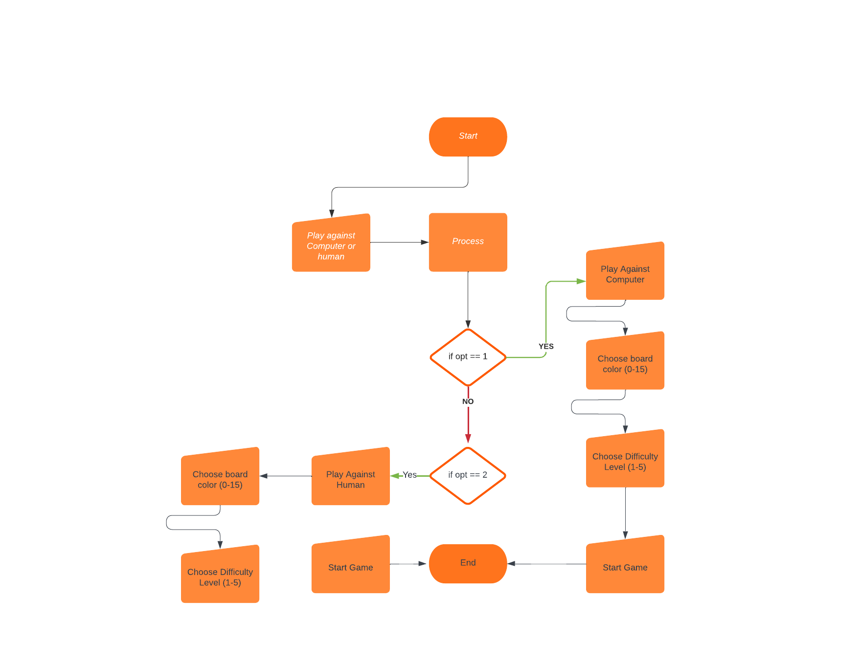

**Snake Game:**

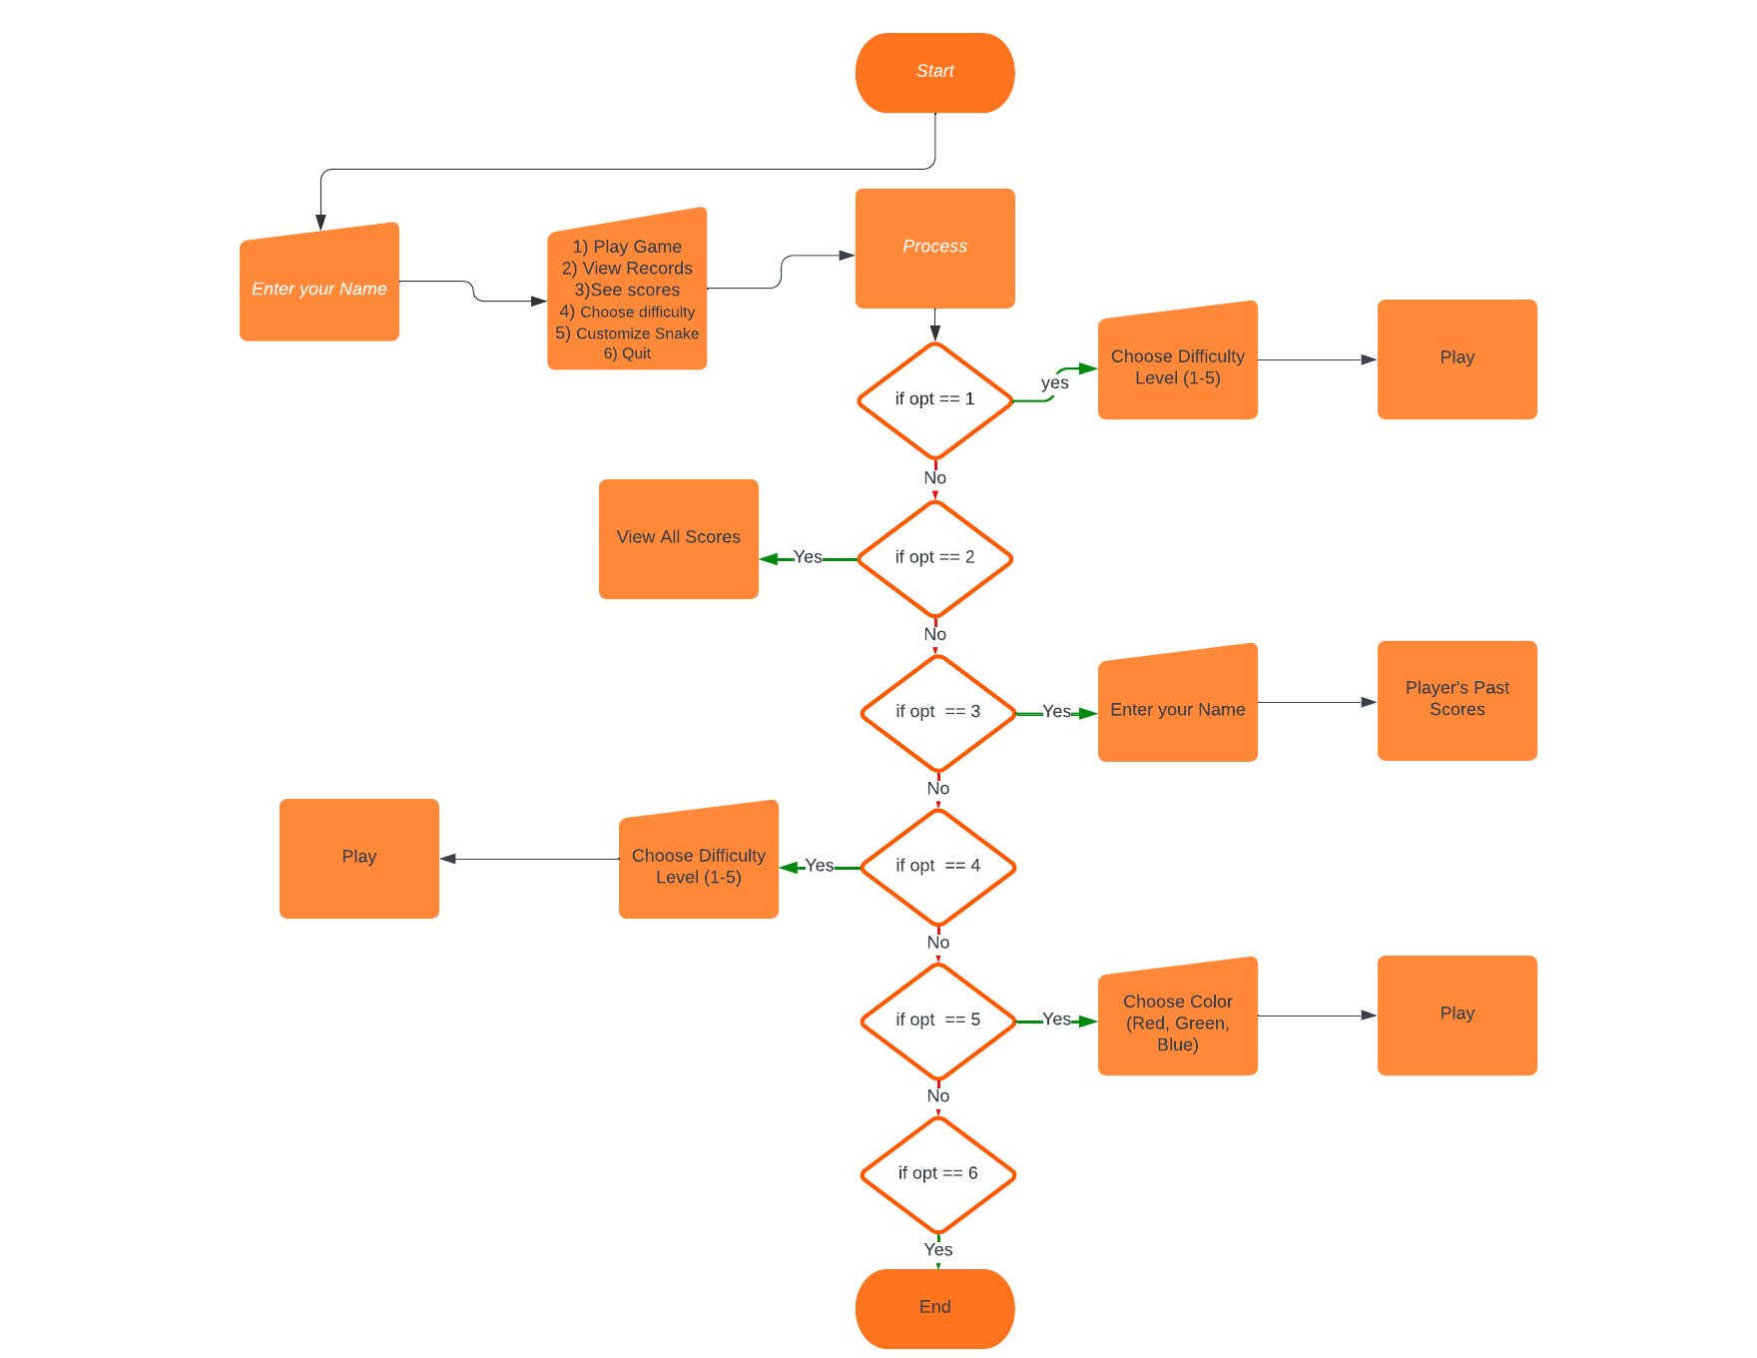



**OUTPUT SCREENSHOTS**

**Snake Game:**

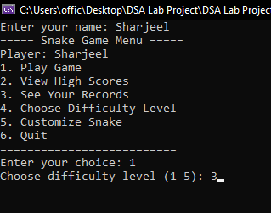

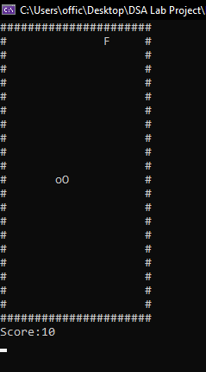

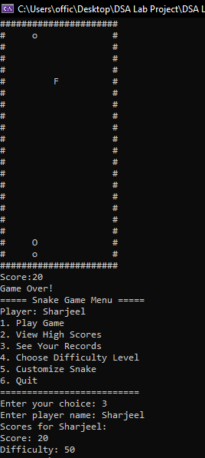

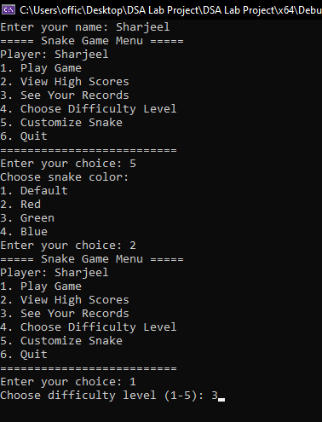

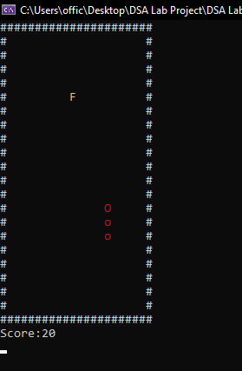

**Tic-Tac-Toe Game:**

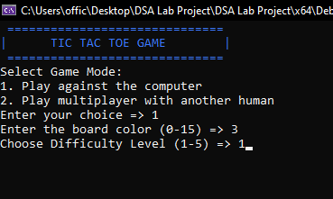

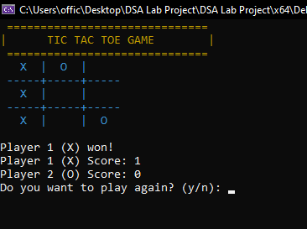

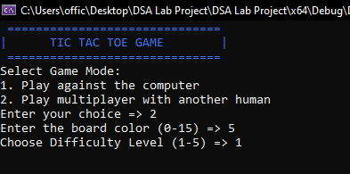

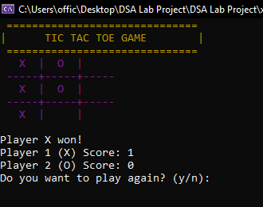



**SYSTEM TESTING**

* Comprehensive testing will be performed to validate the functionality of the games.
* Inputs will be provided to ensure correct handling and responsiveness.
* Different gameplay scenarios will be tested to cover various game outcomes.
* High scores, user records, and customization options will be verified for accuracy.



**CONCLUSION**

The Snake and Tic Tac Toe games project successfully implement two classic games with additional functionalities and customization options. The project demonstrates the effective use of data structures and algorithms to manage game logic, player input, and game state. Through rigorous testing, the project ensures a stable and enjoyable gaming experience for users.